**HARSHTON JUNIOR SCHOOL-MBALE**

**HOLIDAY PACKAGE TERM I-2023 BABY CLASS LEARNING AREA FIVE**

**Name: ……………………………………………………**

1. Shade the sounds.
2. **Read and match the same**

a t

s a

t s

1. **Circle the same sound.**

a n a

m m o

t b b

**LEARNING AREA THREE**

1. Shade things used to clean.

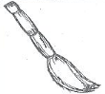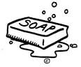



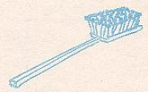

1. 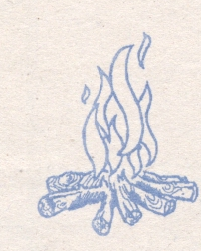Match the same.



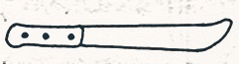









1. Circle the same.

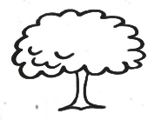



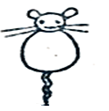

**LEARNING AREA TWO**

1. Trace a house.
2. Match the same houses.





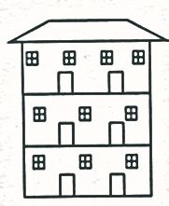

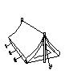









1. Shade parts of the house.



**LEARNING AREA FOUR**

**1. Write number 2**

|  |  |  |  |  |  |
| --- | --- | --- | --- | --- | --- |
| 0 | 1 | 2 | 3 | 4 | 5 |
|  |  |  |  |  |  |
|  |  |  |  |  |  |
|  |  |  |  |  |  |
|  |  |  |  |  |  |
|  |  |  |  |  |  |
|  |  |  |  |  |  |

2. **Copy and draw shapes.**

|  |  |
| --- | --- |
|  |  |
|  |  |
|  |  |

3. Match the same numbers.

1 3 ……………

4 2 ……………

2 4 ………………………..

3 1 ………………………..